

National Textile University

Department of Computer Science

Subject:

Operating System

Submitted to:

Sir Nasir

Submitted by:

Khizar Hameed

Reg number:

23-NTU-CS-1169

Lab no:

03

Semester:

5th

**Program 1: Print PID and PPID**

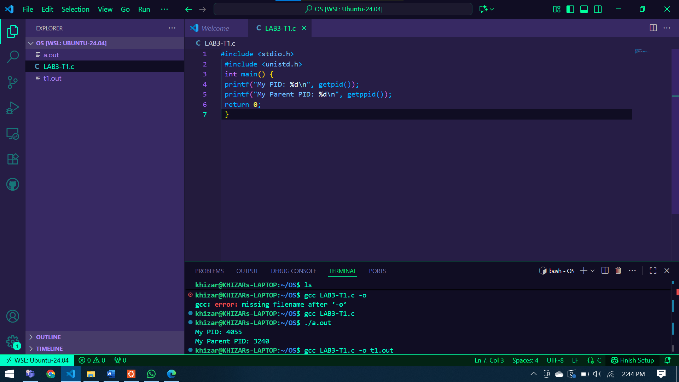

**Program 2: Fork – Creating Child Process**

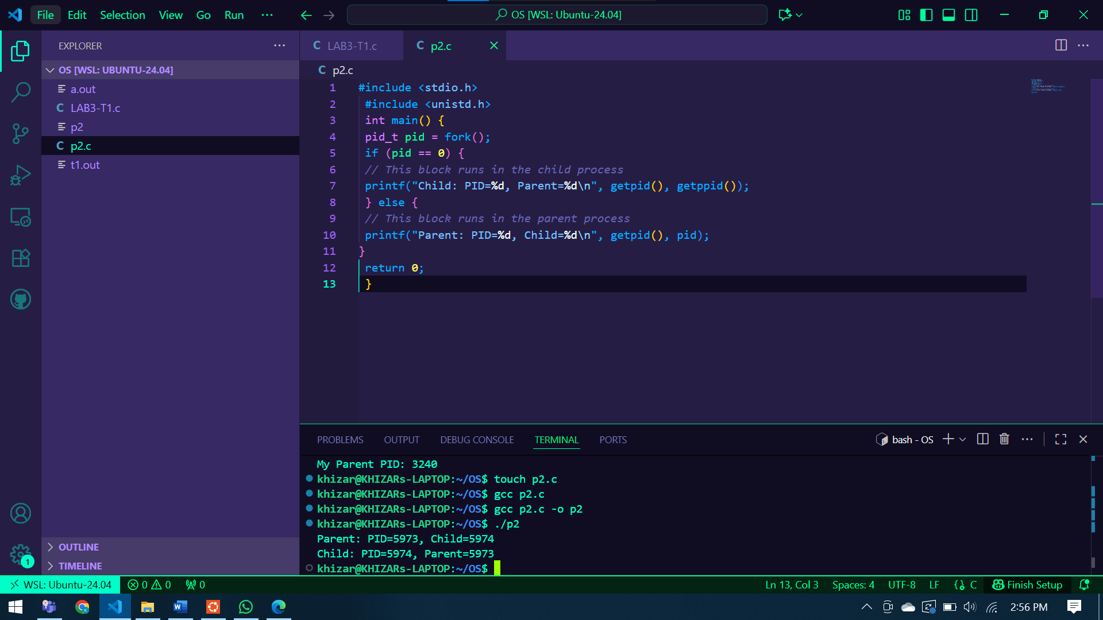

**Program 3: Excel – Replacing a Process**

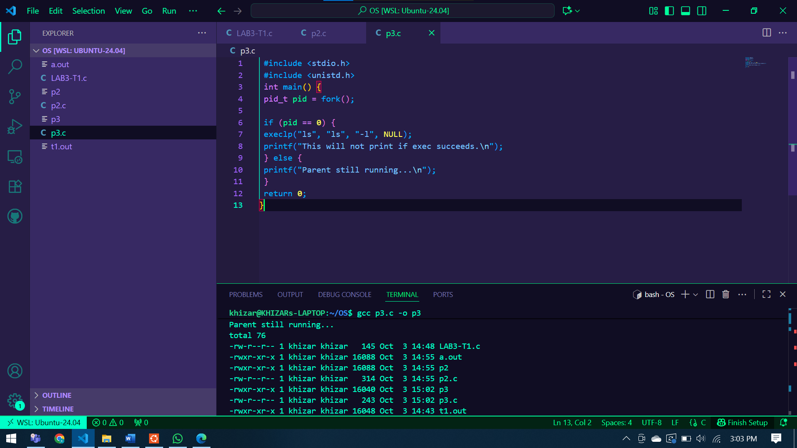

**Program 4: Wait – Synchronization**

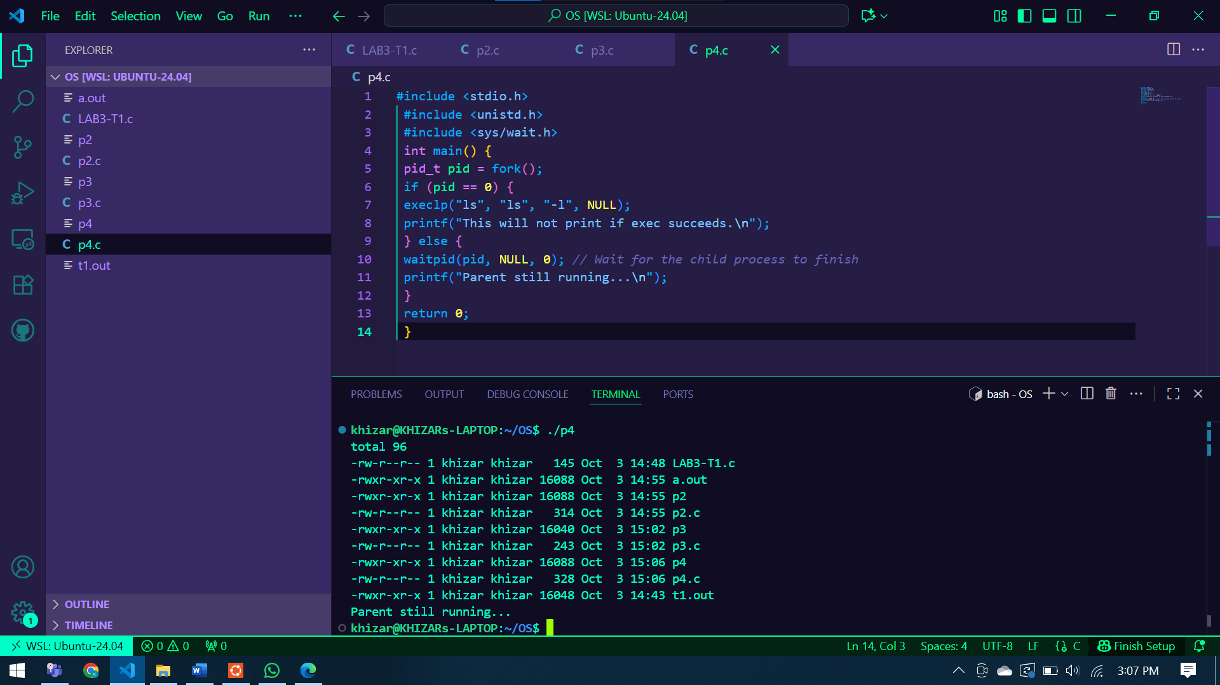

**Linux Process Commands**

**2.1 Viewing Processes**

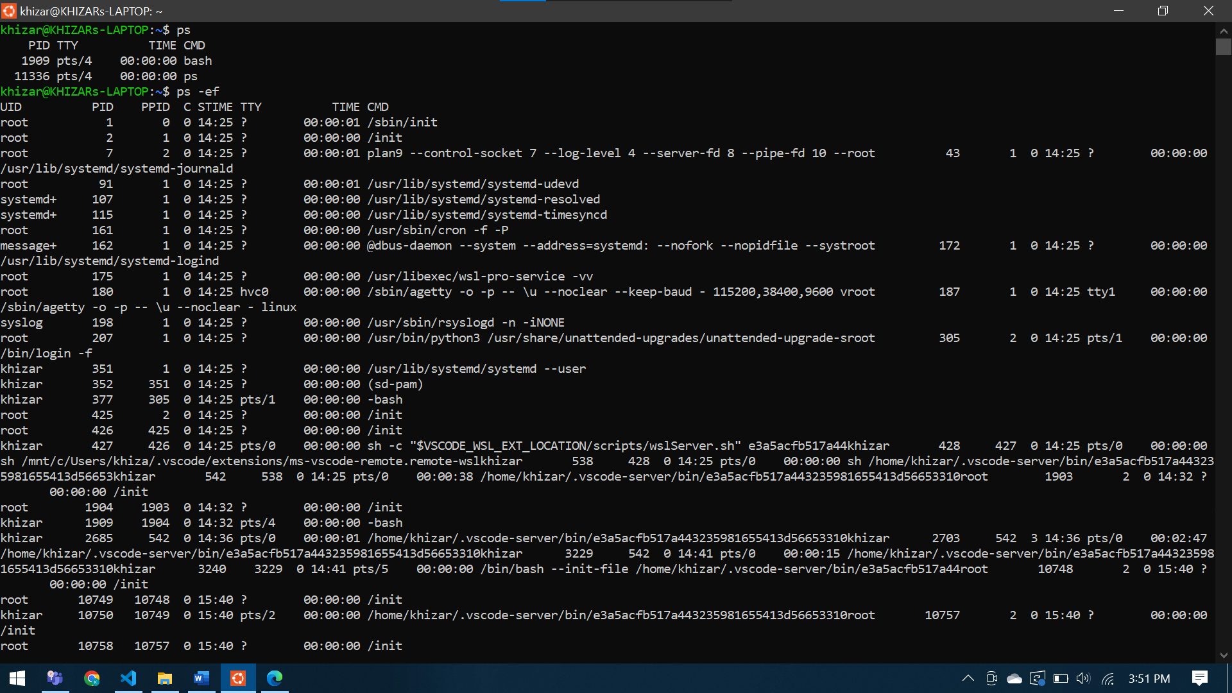

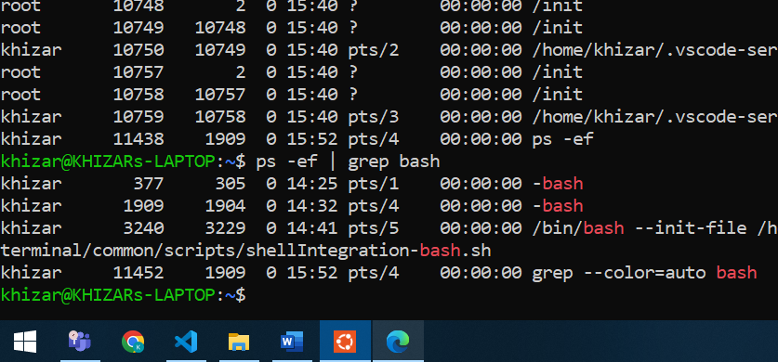

**2.2 Monitoring Processes Interactively**

**2.3 Foreground and Background Jobs**

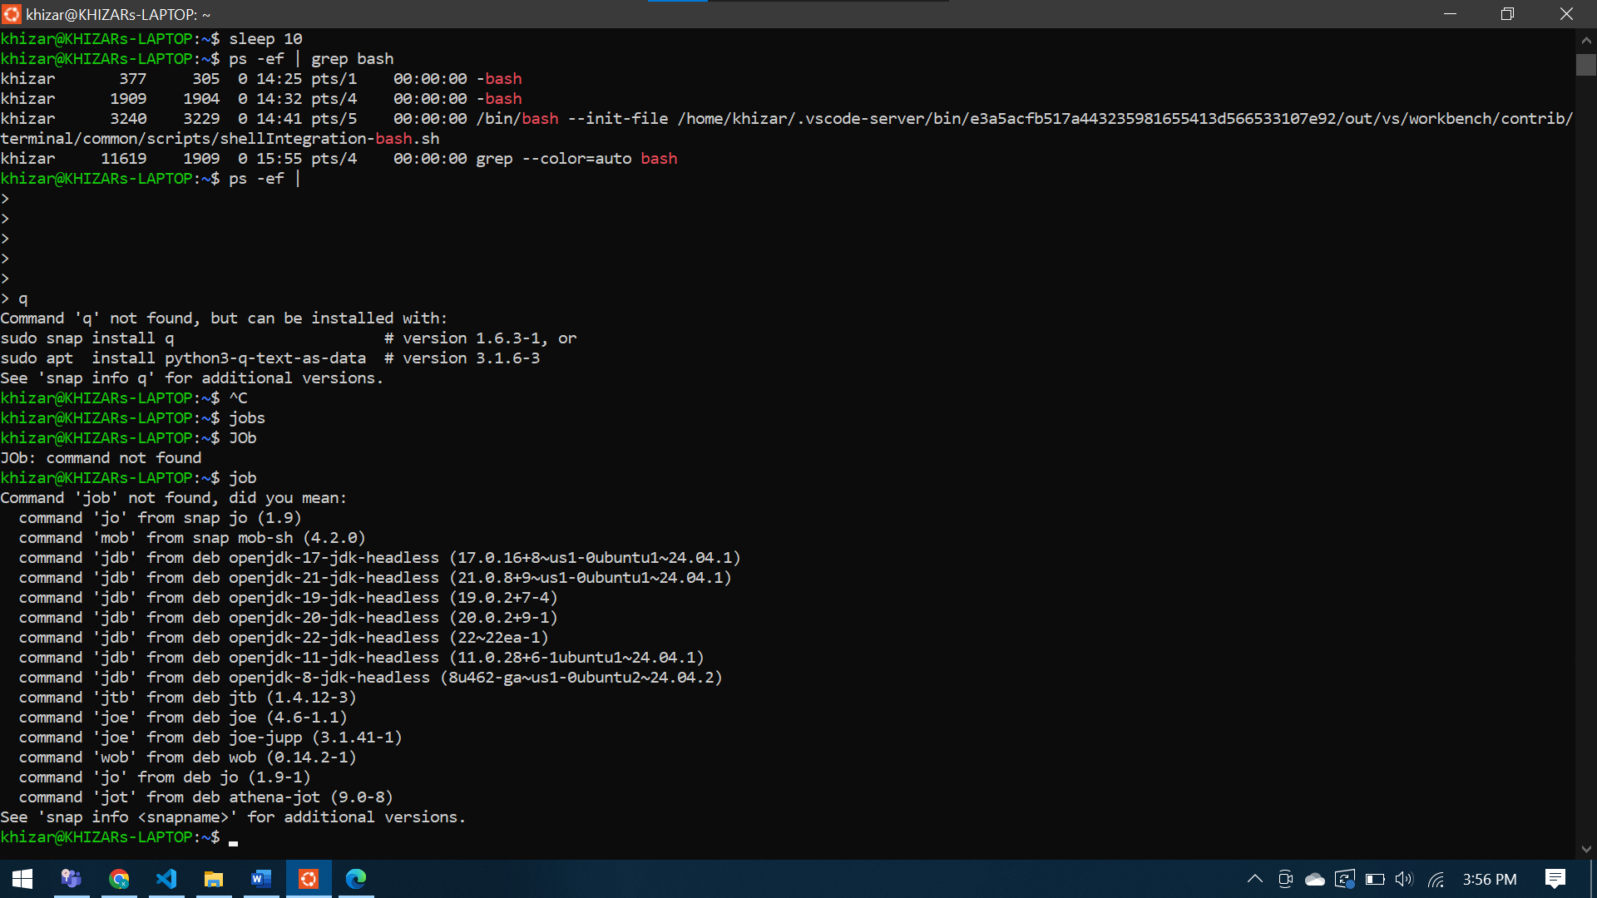

**2.4 Process Identification**

